Mozambique

## Population Data

The data set shows the political stability estimate of the country each year.

## # A tibble: 23 x 5  
## country iso3c date population popCategory5  
## <chr> <chr> <dbl> <dbl> <chr>   
## 1 Mozambique MOZ 1996 15960442 small   
## 2 Mozambique MOZ 1997 16397183 small   
## 3 Mozambique MOZ 1998 16813949 small   
## 4 Mozambique MOZ 1999 17244188 small   
## 5 Mozambique MOZ 2000 17711927 small   
## 6 Mozambique MOZ 2001 18221888 small   
## 7 Mozambique MOZ 2002 18764155 small   
## 8 Mozambique MOZ 2003 19331100 small   
## 9 Mozambique MOZ 2004 19910552 small   
## 10 Mozambique MOZ 2005 20493925 small   
## 11 Mozambique MOZ 2006 21080110 small   
## 12 Mozambique MOZ 2007 21673316 small   
## 13 Mozambique MOZ 2008 22276596 small   
## 14 Mozambique MOZ 2009 22894710 small   
## 15 Mozambique MOZ 2010 23531574 small   
## 16 Mozambique MOZ 2011 24187487 small   
## 17 Mozambique MOZ 2012 24862648 small   
## 18 Mozambique MOZ 2013 25560725 medium   
## 19 Mozambique MOZ 2014 26286163 medium   
## 20 Mozambique MOZ 2015 27042002 medium   
## 21 Mozambique MOZ 2016 27829942 medium   
## 22 Mozambique MOZ 2017 28649007 medium   
## 23 Mozambique MOZ 2018 29495962 medium

# Population growth data

## # A tibble: 23 x 5  
## country iso3c date popGrowth popGrowthCat5   
## <chr> <chr> <dbl> <dbl> <chr>   
## 1 Mozambique MOZ 1996 3.04 high growth rate  
## 2 Mozambique MOZ 1997 2.70 high growth rate  
## 3 Mozambique MOZ 1998 2.51 high growth rate  
## 4 Mozambique MOZ 1999 2.53 high growth rate  
## 5 Mozambique MOZ 2000 2.68 high growth rate  
## 6 Mozambique MOZ 2001 2.84 high growth rate  
## 7 Mozambique MOZ 2002 2.93 high growth rate  
## 8 Mozambique MOZ 2003 2.98 high growth rate  
## 9 Mozambique MOZ 2004 2.95 high growth rate  
## 10 Mozambique MOZ 2005 2.89 high growth rate  
## 11 Mozambique MOZ 2006 2.82 high growth rate  
## 12 Mozambique MOZ 2007 2.78 high growth rate  
## 13 Mozambique MOZ 2008 2.75 high growth rate  
## 14 Mozambique MOZ 2009 2.74 high growth rate  
## 15 Mozambique MOZ 2010 2.74 high growth rate  
## 16 Mozambique MOZ 2011 2.75 high growth rate  
## 17 Mozambique MOZ 2012 2.75 high growth rate  
## 18 Mozambique MOZ 2013 2.77 high growth rate  
## 19 Mozambique MOZ 2014 2.80 high growth rate  
## 20 Mozambique MOZ 2015 2.83 high growth rate  
## 21 Mozambique MOZ 2016 2.87 high growth rate  
## 22 Mozambique MOZ 2017 2.90 high growth rate  
## 23 Mozambique MOZ 2018 2.91 high growth rate

## Population trend

The plot shows the population trend of the country.

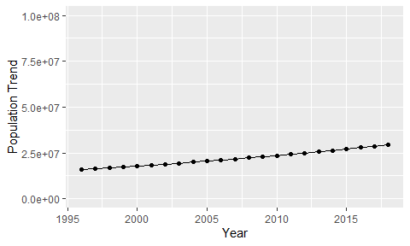

Political Stability Trend

# Population growth trend

The plot shows the population growth rate trend of the country.

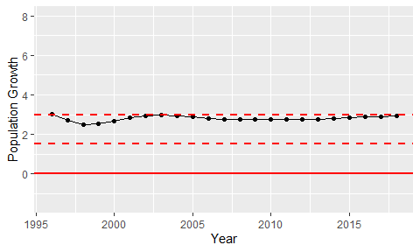

Population Growth Trend